Rulebook – Arena

Contents

A Knight’s Duty 1

To Battle! 1

Warming up (Setup) 1

Be Swift (Round Overview) 2

Be Smart (Weapons) 2

Be True (Attacking) 2

The Last One Standing (Winning the game) 2

The Gear (Game Components) 3

Game Variants 4

Taking cover 4

Tournament 4

# A Knight’s Duty

For a Knight, his foremost duty is to uphold and protect your honor and the honor of his house. As a squire and apprentice, the royal tournament is where you’ll earn your chance to be respected, and hopefully, one day defend your Lord. Today is the day that blade and spear and bow meet destiny.

May your moves be smart, may your strikes be true, and may you be the last one standing.

# To Battle!

There are many ways to prove yourself:

* (2 players only) ***Duel:*** 1 on 1 Combat.
* ***Banner Battle:*** Teams of 2 or 3 players under the same banner.
* ***Royal Rumble:*** Up to 6 players free-for-all.

The last player or team standing wins the battle.

# Warming up (Setup)

1. Each player choose a *Squire*, and take the set of tokens and the set of cards with the matching sigil on it.
2. Assemble the arena by matching the letters at the edge of the pieces together (i.e., A-A, B-B and C-C).
3. Place the *Player Mat* on the table, somewhere easily accessible by all players.
4. If playing *Banner Battle*, each team represents a House, and must choose a Motto (i.e. “Together we are strong”, or “We serve a higher purpose”, etc.).  
   *We highly encourage choosing banner colors and House Lord’s name.*
5. Place each player *Inspiration* marker **face up** on the *Player Mat*, on that player *Inspiration* slot.
6. Each player choose any of the tiles with a symbol as their starting position.
7. Each player choose their starting weapon.

# Be Swift (Round Overview)

Each round, every player gets to make two actions, by placing the **small** tokens **face down** on the arena, on tiles adjacent to you or your tokens.

Tokens **can** be played on top of other player’s token, and resolve normally.

The actions can be:

1. **Move**, by placing a ( ) token.
2. **Defend**, by placing a ( ) token.
3. **Attack**, by placing your current weapon token ( , or )
4. **Change Weapon**, by placing a different weapon token.

Players can expend their **Inspiration** to make one more action this round, by turning the marker face down.

When every player has placed their tokens, **reveal** them. Then:

1. **Move** squires. *Various squires can occupy the same tile.*
2. **Change weapons**.
3. **Attack**, if in range.

Resolve all attacks, one a time, even if the attacker was hit this turn.

# Be Smart (Weapons)

Each weapon has its own range and chance to hit. It goes as follows:

|  |  |  |
| --- | --- | --- |
| Weapon | Range | Cards |
| Sword | 0 to 1 Tiles | 1 Heart + 1 Dodge |
| Spear | 2 to 3 Tiles | 1 Heart + 2 Dodge |
| Bow | 4 to 6 Tiles | 1 Heart + 3 Dodge |

Track your current weapon by placing the **larger** weapon token on the *Player Mat*, on the *Weapon* slot.

# Be True (Attacking)

If an attack is made and there are other squires in range, resolve it by doing the following:

1. **Choose** the target, if more than one is possible.
2. The target shuffles together *Dodge* and *Heart* cards, in the amount instructed in the **attacker** weapon description.
3. **Check if target defended**. If the target has placed a *Defend* token, he **can choose to** swap his *Heart* card for one *Shield* card, and reshuffle. Only one *Shield* can be used for each *Defend* token each round.
4. **Attacker** picks a card. If it is:
   1. **Dodge**, the attack missed.
   2. **Shield**, the attack is defended. Discard the *Shield* card and **Make the attack again.**
   3. **Heart**, the attack hits, and the target is knocked out for the remaining of the battle. Remove that squire token from the arena.
5. If the attack was successful, turn the attacker’s **Inspiration** marker **face up**.

# The Last One Standing (Winning the game)

The battle ends when only one player or team is still standing in the arena.

# The Gear (Game Components)

1. Board
   1. (3 or 6) Arena pieces
   2. 2 Cover pieces
2. Tokens (6 sets in total)
   1. 1 *Squire* Token
   2. 3 Small *Movement* Tokens
   3. 2 Small *Sword* Tokens
   4. 2 Small *Spear* Tokens
   5. 2 Small *Bow* Tokens
   6. 2 Small *Shield* Tokens
   7. 1 Large *Sword* Tokens
   8. 1 Large *Spear* Tokens
   9. 1 Large *Bow* Tokens
   10. 1 *Inspiration* Token
3. Cards (6 sets in total)
   1. 4 *Dodge* cards
   2. 1 *Heart* cards
   3. 1 *Shield* cards
4. Player Mat

# Game Variants

## Taking cover

On the setup fase, after assembling the arena (step 2), do the following:

* 1. Choose if and how many *Cover* pieces will be placed. Then, place the pieces on any tile in the arena. This process can be done at random, by mutual decision, or even by shouting match.

When **Attacking**, before checking the odds (step 2), do the following:

1. Check the **Line-of-Sight**. There are 3 types:
   1. **No cover:** There’s no cover between the attacker and the target. **Nothing happens.**  
      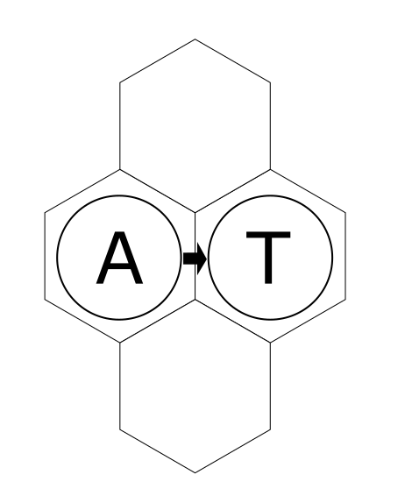 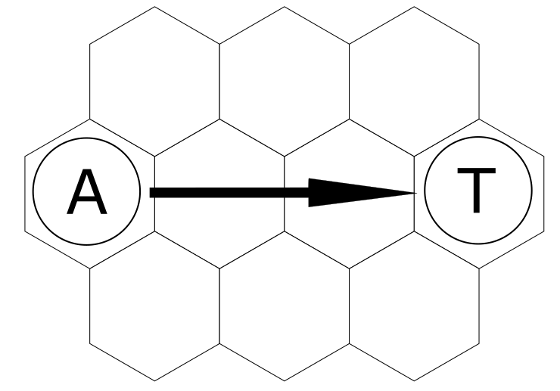
   2. **Half cover:** There’s cover between the attacker and the target, but a line can still be drawn between their tiles. **Add one more Dodge card than you normally would.**  
      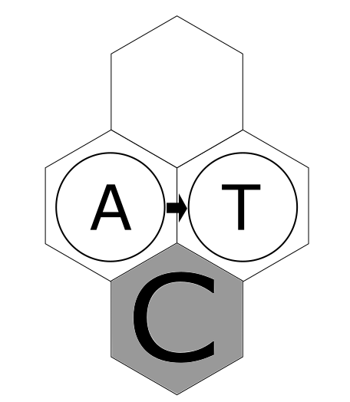 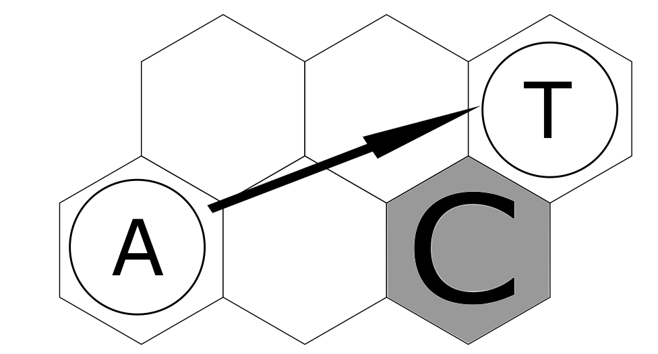
   3. **Full cover:** There’s cover between the attacker and the target, and no line can me drawn between their tiles. **You cannot attack this target. Pick another if possible.**  
      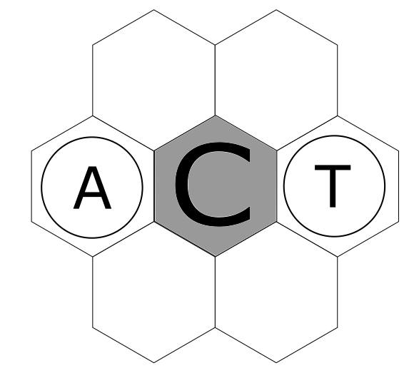 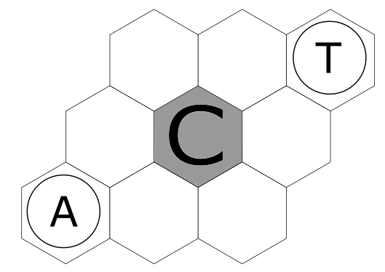

## Tournament

When a *Squire* gets knocked out, assign that player points, in the order they get knocked out, i.e.:

Knocked out 1st = 1 point,

Knocked out 2nd = 2 points,

Knocked out 3rd = 3 points, an so on.

If two or more players get knocked out in the same round, they get the same amount of points.

The last one standing gains points for the number of players in that round, plus 1.

The winner is whoever gets the most point after a series of battles.